Titus Roktok: HB107/G/14739/21

Willy P Mukuvi : HB107/G/14740/21

Herrimah Ongesso: HB107/G/14766/21

Adeola S Weche: HB107/G/14724/21

George Ngure: HB107/G/14694/21

Duration of project: 3weeks

Number of participants: 5

INTRODUCTION

The Glock 18 is a machine pistol of Austrian origin. It is a machine pistol conversion of the Glock 17 pistol. Although the Glock 18 is an uncommon firearm, its 33 round capacity magazines are often used in Glock 17 full size and Glock 19 compact pistols.

Description

The Glock 18 is a Glock 17 full size 9mm pistol with the added ability for automatic fire. The Glock 18 has the same dimensions as the Glock 17 and looks very similar. Due to its high rate of fire it is often used with special 33 round magazines. Most Glock 18's are fitted with a compensated barrel in order to reduce recoil. In order to make the Glock 18 more controllable it is often fitted with an aftermarket detachable shoulder stock.

**Firepower**

The Glock 18 is a select fire pistol. It has the ability for semi-automatic fire and full automatic fire. The cyclic rate of fire is very high at 1.100 to 1.200 rpm. This makes the Glock 18 difficult to control. Effective use of a machine pistol requires a skilled operator and a lot of practice.

**Users**

The Glock 18 is a weapon for specialist users. Most of them being counter terrorist or VIP protection units. A machine pistol suits a niche application. Even in the hands of a skilled operator there are few situations in which a machine pistol achieves better results than a pistol or sub machine gun. For these reasons the production number of the Glock 18 is insignificant compared to other Glock models.

**General Facts For Glock 18**

Origin: Austria

Type: Machine pistol

Caliber: 9x19mm Parabellum

Feed system: 33 round detachable magazine

: 17 and 19 round capacity available

Barrel length: 114 mm

Rifling: 250 mm hexagonal right hand twist

Muzzle velocity: 375 m/s

Action: Short recoil, locked breech, tilting barrel

Fire selector: 1 - F

Rate of fire: 1.100-1.200rpm

Dimensions: Length 186 mm

: Width 30mm

: Height 138mm

: Weight 0.620kg empty, 0.900 kg loaded with 17 round magazine

Sights

Mechanical

Iron sights

Sight radius: 165mm

Entered service: Late 1980's

Status: Limited service

Development: Mid 1980's

Developer: Austria - Glock

Production: 1986 - present

Producer: Austria - Glock

Number produced: Produced in limited numbers

**Parameters of G18 pistol**

The Glock 18, like other Glock models, has several standard specifications and features. However, specific details may vary depending on the generation of the pistol. Here are some general parameters of the Glock 18:

Caliber: 9x19mm Parabellum

Action: Short Recoil, Locked Breech

Capacity: The standard magazine capacity is typically 17 rounds for the Glock 17. However, extended magazines with higher capacities are available, often holding 30 rounds or more.

Barrel Length: Around 4.49 inches (114 mm)

Weight (Unloaded): Approximately 22.22 ounces (630 grams) for the Glock 17; the Glock 18 may have a slightly different weight due to additional components for the selective-fire capability.

Length: Approximately 7.95 inches (202 mm)

Height: Around 5.47 inches (139 mm)

Width: Approximately 1.26 inches (32 mm)

Sights: Fixed front and rear sights, though various sight options may be available depending on the model and user preferences.

**Purpose of the handgun**

Operating System: Safe Action System with a striker-fired mechanism.

Selective-Fire Capability: The most distinctive feature of the Glock 18 is its ability to switch between semi-automatic and fully automatic firing modes.

It's important to note that Glock has produced multiple generations of their pistols, and specifications can vary between these generations. Additionally, local regulations may influence the features and configurations available in different regions. Always refer to the specific model and generation of the Glock 18 you are interested in for the most accurate and up-to-date information.

Military and Law Enforcement: The Glock 18 is often adopted by military and law enforcement agencies that require a sidearm with the option for fully automatic fire. The selective-fire capability provides versatility in different operational scenarios.

Special Operations: Special operations units may use the Glock 18 for specific missions where a compact, high-capacity, and fully automatic pistol is advantageous. Its design makes it suitable for close-quarters combat and other specialized tasks.

Security Details: In some security and personal protection scenarios, a fully automatic pistol can be considered an asset. The Glock 18 may be chosen for its compact size, reliability, and the ability to deliver rapid bursts of fire.

Training: While the fully automatic capability is a notable feature, the Glock 18 can also be used in training scenarios to simulate the handling and control of automatic fire. This helps military and law enforcement personnel become familiar with the challenges and requirements of using fully automatic weapons.

Collectors and Enthusiasts: Some individuals may acquire the Glock 18 for collecting purposes or as part of a firearms enthusiast's collection. The unique feature of fully automatic fire adds to its appeal among gun enthusiasts

**Python code**

import math

import matplotlib.pyplot as plt

import numpy as np

# Constants

m = 0.0075  # mass of the bullet in kg

k = 0.01  # air resistance constant in kg/s

g = 9.81  # acceleration due to gravity in m/s^2

v0 = 100  # initial velocity in m/s

h = 1    # initial height in m

dt = 0.01 # time step in s

# Angle of shooting

angles = [ math.radians(90), -math.pi, math.pi, math.radians(120), math.radians(40)]  # angles in radians

plots = []

for theta in angles:

    # Initialize variables

    x = 0     # horizontal position

    y = h     # vertical position

    vx = v0 * math.cos(theta)  # horizontal component of velocity

    vy = v0 * math.sin(theta)  # vertical component of velocity

    # Lists to store trajectory data

    xs = [x]

    ys = [y]

    # Euler method

    while y > 0:

        vx = vx - (k/m)*vx*dt

        vy = vy - (k/m)*vy*dt - g*dt

        x = x + vx*dt

        y = y + vy*dt/2

        xs.append(x)

        ys.append(y)

    plots.append({"x": xs, "y": ys, "theta": theta})

# Plotting the trajectory

plt.figure(figsize=(10,50))

for plot in plots:

    xs = plot["x"]

    ys = plot["y"]

    theta = plot["theta"]

    plt.plot(xs, ys, label=("theta " + str(theta)))

    plt.legend()

plt.title('Trajectory of a Bullet')

plt.xlabel('Distance (m)')

plt.ylabel('Height (m)')

plt.grid(True)

plt.show()

Graph

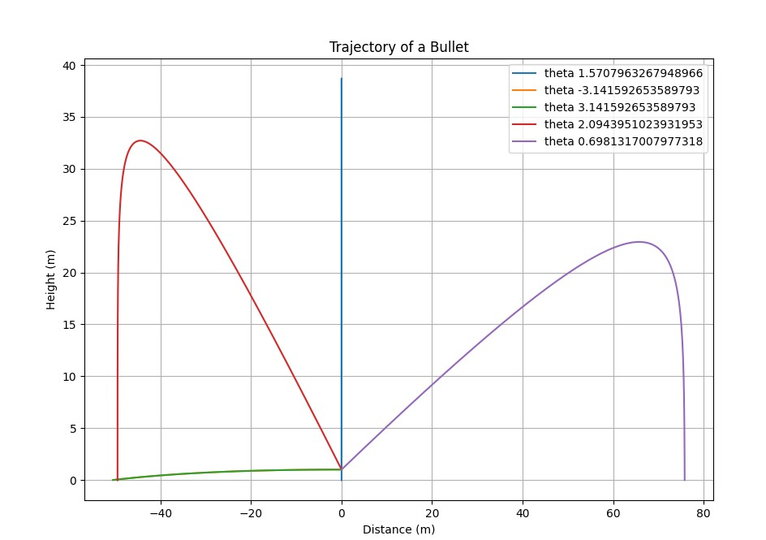

References

<https://eu.glock.com/en/products/pistols/g18>

<https://www.militarytoday.com/firearms/glock_18.htm>

<http://Weaponsystems.net>

<https://www.gun-tests.com/handguns/pistols/a-history-of-glock-generations-2/>